Table of Contents

PART ONE – OBJECTIVE

PART TWO – OUTPUT

PART THREE – ASSIGNMENT QUESTIONS

**Hadoop Installation:**

Enabling port:



Check for Java availability:

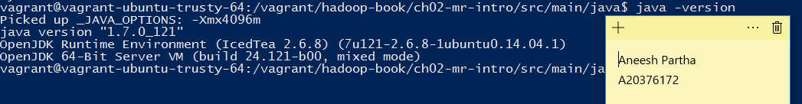

Check after Hadoop is installed in the system:

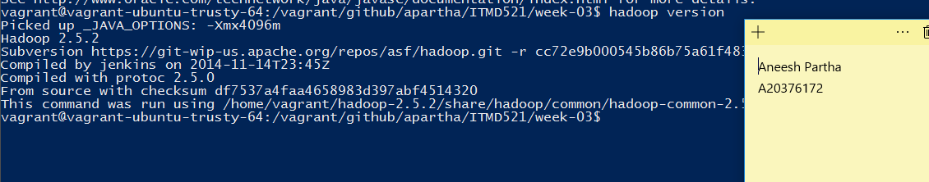

Below paths are set in .bashrc:



Contents of hdfs-site.xml:

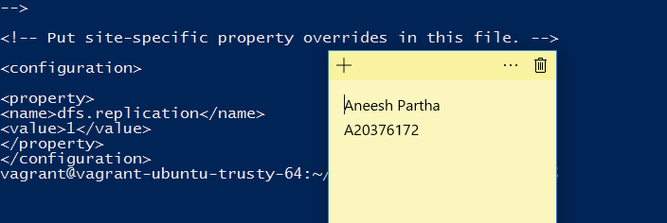

Contents of core-site.xml

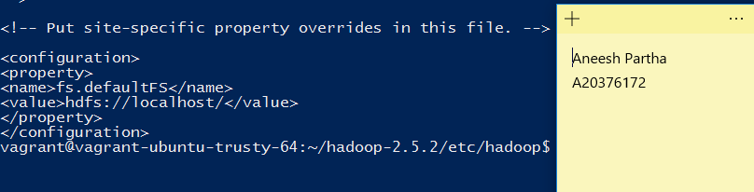

Contents of Mapred-site.xml:

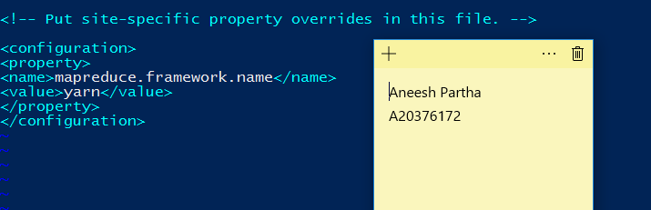

Contents of yarn-site.xml:

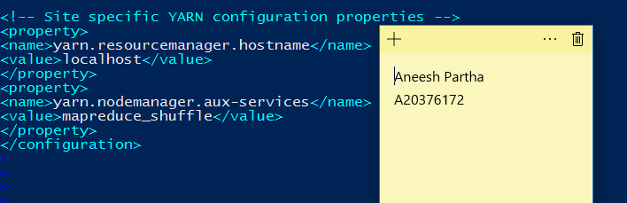

Processes running in the system:

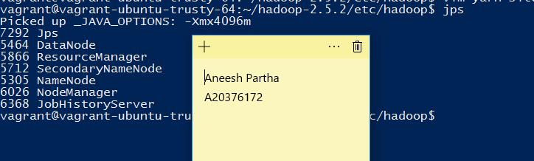

Hadoop file system:

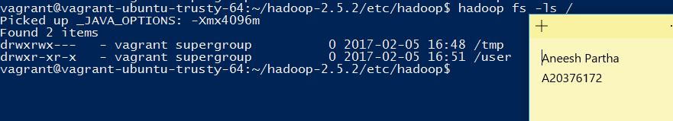

**Analysis of data sets using Hadoop:**

**Without combiner:**

**1990,1991,1992,1993 data sets:**

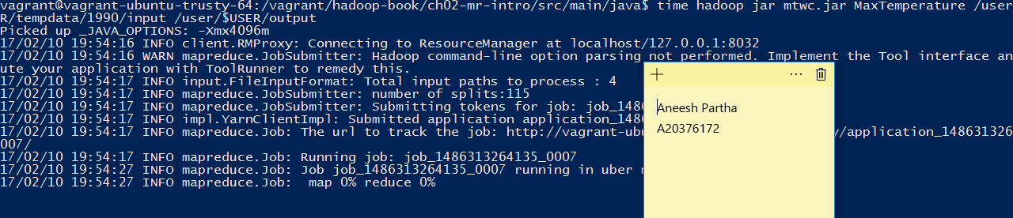

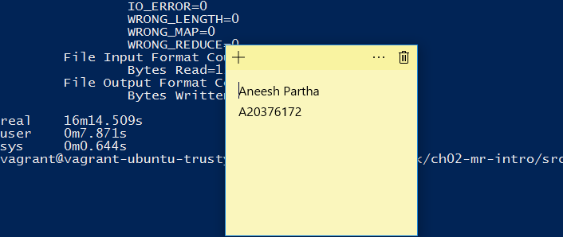

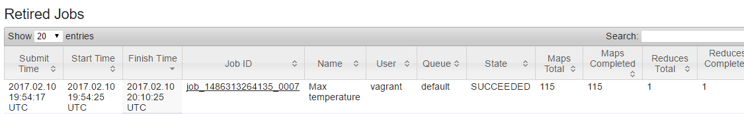

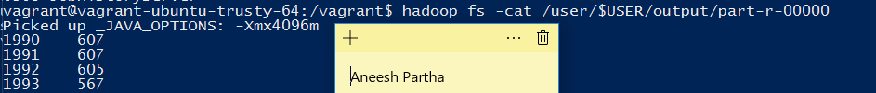

**1990 and 1992 data sets:**

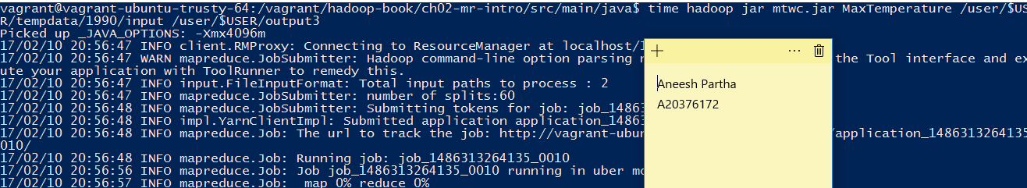

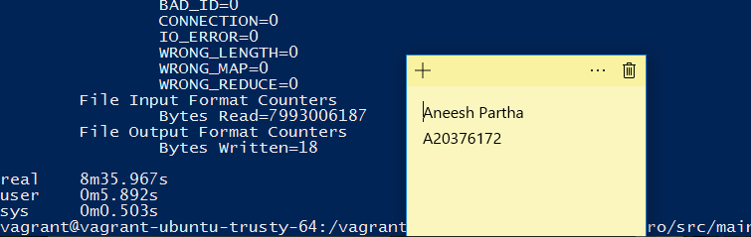

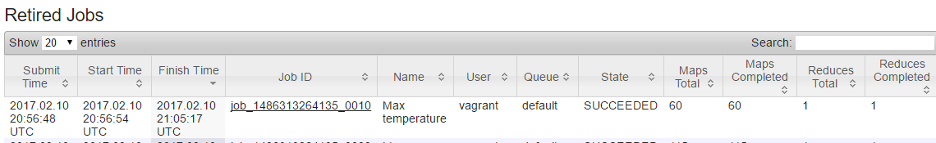



**1990 data set**

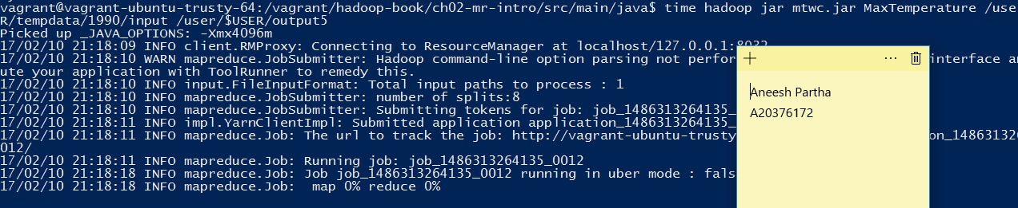

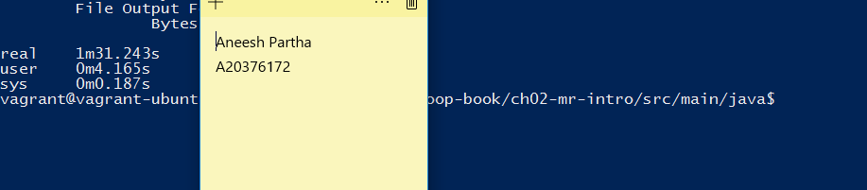

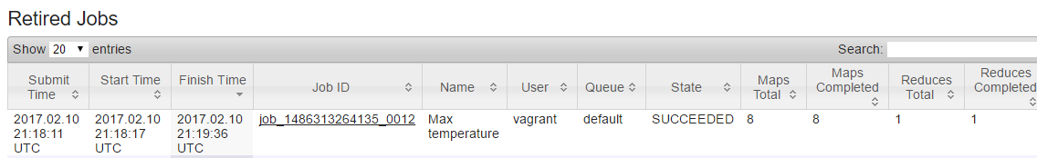

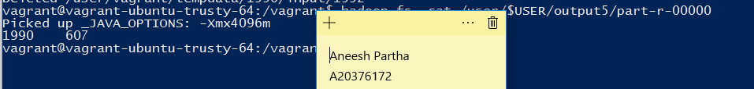

**With combiner:**

**1990,1991,1992 and 1993 data sets**

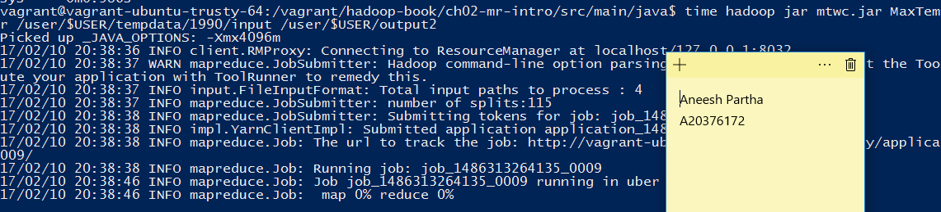

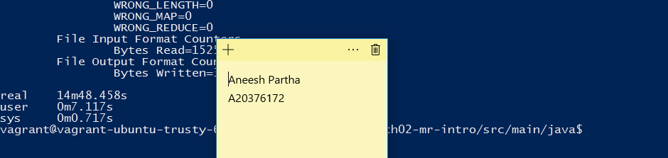

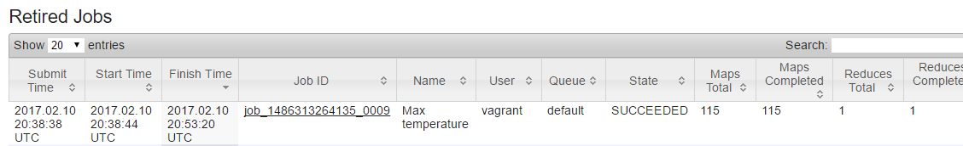

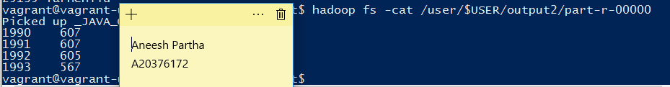

**1990,1992 data sets**

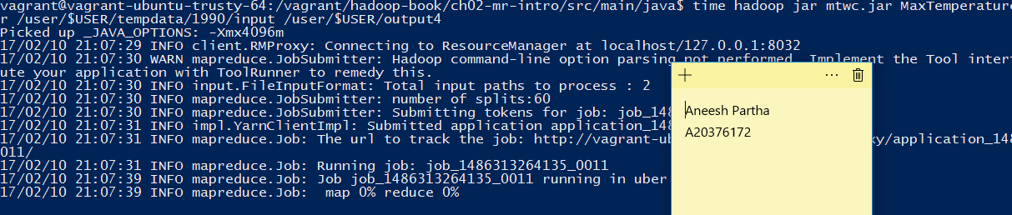

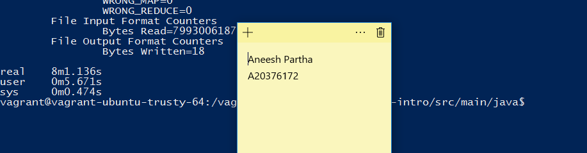

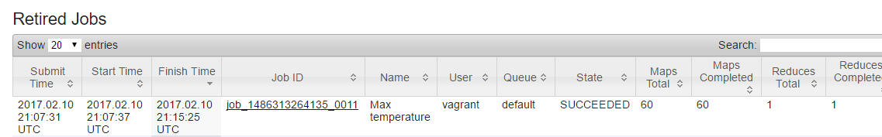

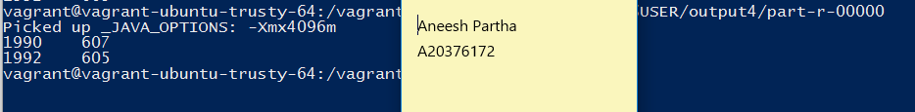

**1990 data set**

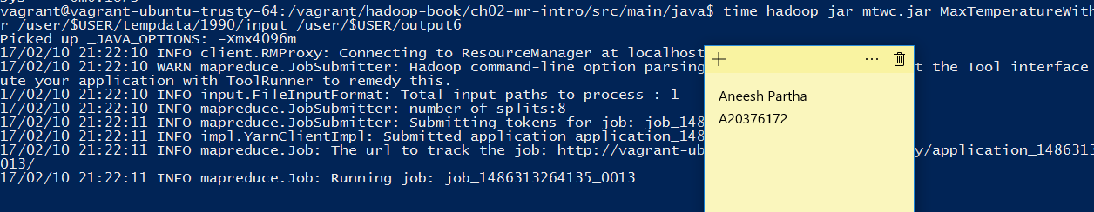

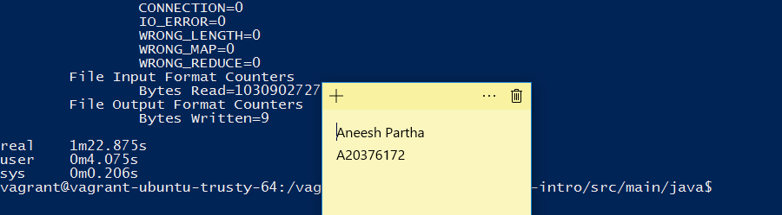

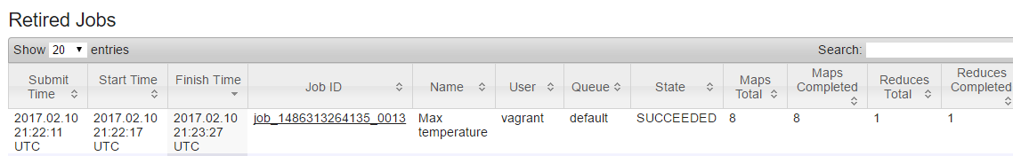



**Comparison of time taken:**

|  |  |  |
| --- | --- | --- |
| **Dataset** | **Execution in Hadoop** | **Execution in hadoop using combiner** |
| 1990 | 1.31 | 1.22 |
| 1990 and 1992 | 8.35 | 8.1 |
| 1990,1991,1992 and 1993 | 16.14 | 14.48 |